www.sussexca.org.uk
Sussex Cyclists’ Association

Open 10 mile Time Trial Saturday 7th May 2022
Course G10/97

Incorporating Sussex Individual, Veterans and Team Championships

Event Secretary: Stuart Bettis

43 Greystone Avenue, Worthing, BN13 1LR
Email: stuart.bettis@hotmail.co.uk
Tel: 07732 818817

Promoted for and on behalf of Cycling Time Trials under it’s rules and regulations

HQ - Cuthman Centre - Steyning

Cuthman Centre
Upper School, Shooting Field
Steyning
BN44 3RX

Open from 06:00

Plenty of parking is available.
Free till 09:00 then pay and display (or Horsham annual parking disc), or park in road by church for free. Numbers at HQ only. After the event please return your race number to the HQ and complete the sign-out sheet.

Route to start:
Right out of the car park, down the Horsham road, Joining the Steyning bypass A283. Proceed North Left and continue West on A283 for 0.7 miles.

Competitors are requested not to warm up on the course after the event has started.

Please note the following CTT regulations and recommendations

Race Numbers

Numbers will be available at the event HQ. Please collect your number when you sign on.

Notice of any additional hazards to be aware of on the course will be displayed next to the signing on sheet

After the event please return your race number to the event HQ in exchange for a cup of tea or coffee.

Body numbers should be fitted in accordance with Regulation 16 and Arm Numbers should be fitted to the upper arm with the number facing forwards (not inwards).

Be aware that “No time may be recorded if the number is incorrectly positioned”.

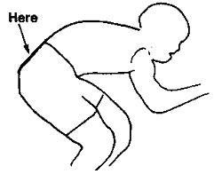

REMEMBER TO SIGN OUT AFTER YOUR RIDE!

Please pay attention to the following Safety Notes

London South District Regulation: No vehicles, except those of the timekeepers and race officials, shall be parked in the vicinity of the start or finish areas.

CTT regulations require that all competitors must wear a properly affixed helmet which must be of hard/soft shell construction. Helmets should conform to internationally accepted safety standards.

Competitors Machines: must have working front and rear lights, either flashing or constant, fitted to their machine in a position clearly visible to other road users and is active while the machine is in use.

Please be aware that there has been road works on the course, and the event may have to use an emergency course.

In the interests of rider safety and in addition to the compulsory front and rear lights, the advisory use of suitable hard shell helmets for competitors over 18 years of age, London South DC strongly recommend that riders do not wear black or dark clothing during any event help on the public road.

Competitors’ Vehicles: No vehicles, except those of timekeepers and event officials, shall be parked in the vicinity of the start or finish (District regulation).

Safety Instructions: Details of any additional hazards not listed on the start sheet will be displayed at the signing on point.

Warming Up: Competitors are requested not to warm up on the course after the event has started.

Observers: Official observers will be stationed around the course to ensure correct procedure (e.g. drafting and safety at roundabouts.

Results: No times will be given out at the finish line.

Additional Safety Instructions

Competitors must exercise extra care at the start and at all roundabouts.
Open 10 mile Time Trial Saturday 7th May 2022
Course G10/97

OFFICIAL TIME KEEPERS

Start: Finish: | Su Balcombe  Richard Meed |  | Brighton Excelsior Lewes Wanderers CC
 |  |  | Prizes

1st Male TT £40 + Ultegra chain (Browns Bikes)
2nd Male TT £30
3rd Male TT £20
4th Male TT NoPinz voucher

1st Lady TT £40 + Ultegra chain (Browns Bikes)
2nd Lady TT £30
3rd Lady TT NoPinz Voucher

1st Male Road Relay Coffee Voucher + No Pinz Voucher
2nd Male Road Hunt Voucher

1st Female Road Relay Coffee Voucher + No Pinz Voucher

1st Vet £20
2nd Vet £15

1st Junior Hunt Voucher + £20

Best newcomer Hunt Voucher

1st team £10 each

1st Tandem £10 each (As only one team)

As a Championship event, this race includes a selection of Trophies, Cups and Medals to be awarded to Sussex CA Riders in various categories. This includes the 10 Mile Shield for the fastest overall and the Dave Henty Cup for the fastest team of three. Full details of all awards can be found on the SCA Website and will be presented at the annual Awards Presentation.

There will also be a photographer on the course who will publish pictures after the event to: https://geosnapshot.com/e/cyclingtimetrials-sussexcyclingassociation

COURSE DIRECTIONS – G10/97 MILES
START on A283 at yellow paint mark 39 yards east of centre of entrance to Hammes Farm (and
Studio) and 0.52 miles west of junction with B2135
Proceed south-eastwards along A283 via Bramber Castle and Beeding Court RBTs to Adur
0.00
Bridge RBT, Shoreham where turn (CHECK) 5.41 Take fourth exit to retrace on A283 via Beeding Court and Bramber Castle RBTs to FINISH at
yellow paint mark 25 yards west of “Public Bridleway” sign and 271 yards before left turn into
Steyning 10.00

Link to Garmin Connect version of the course map G10/97

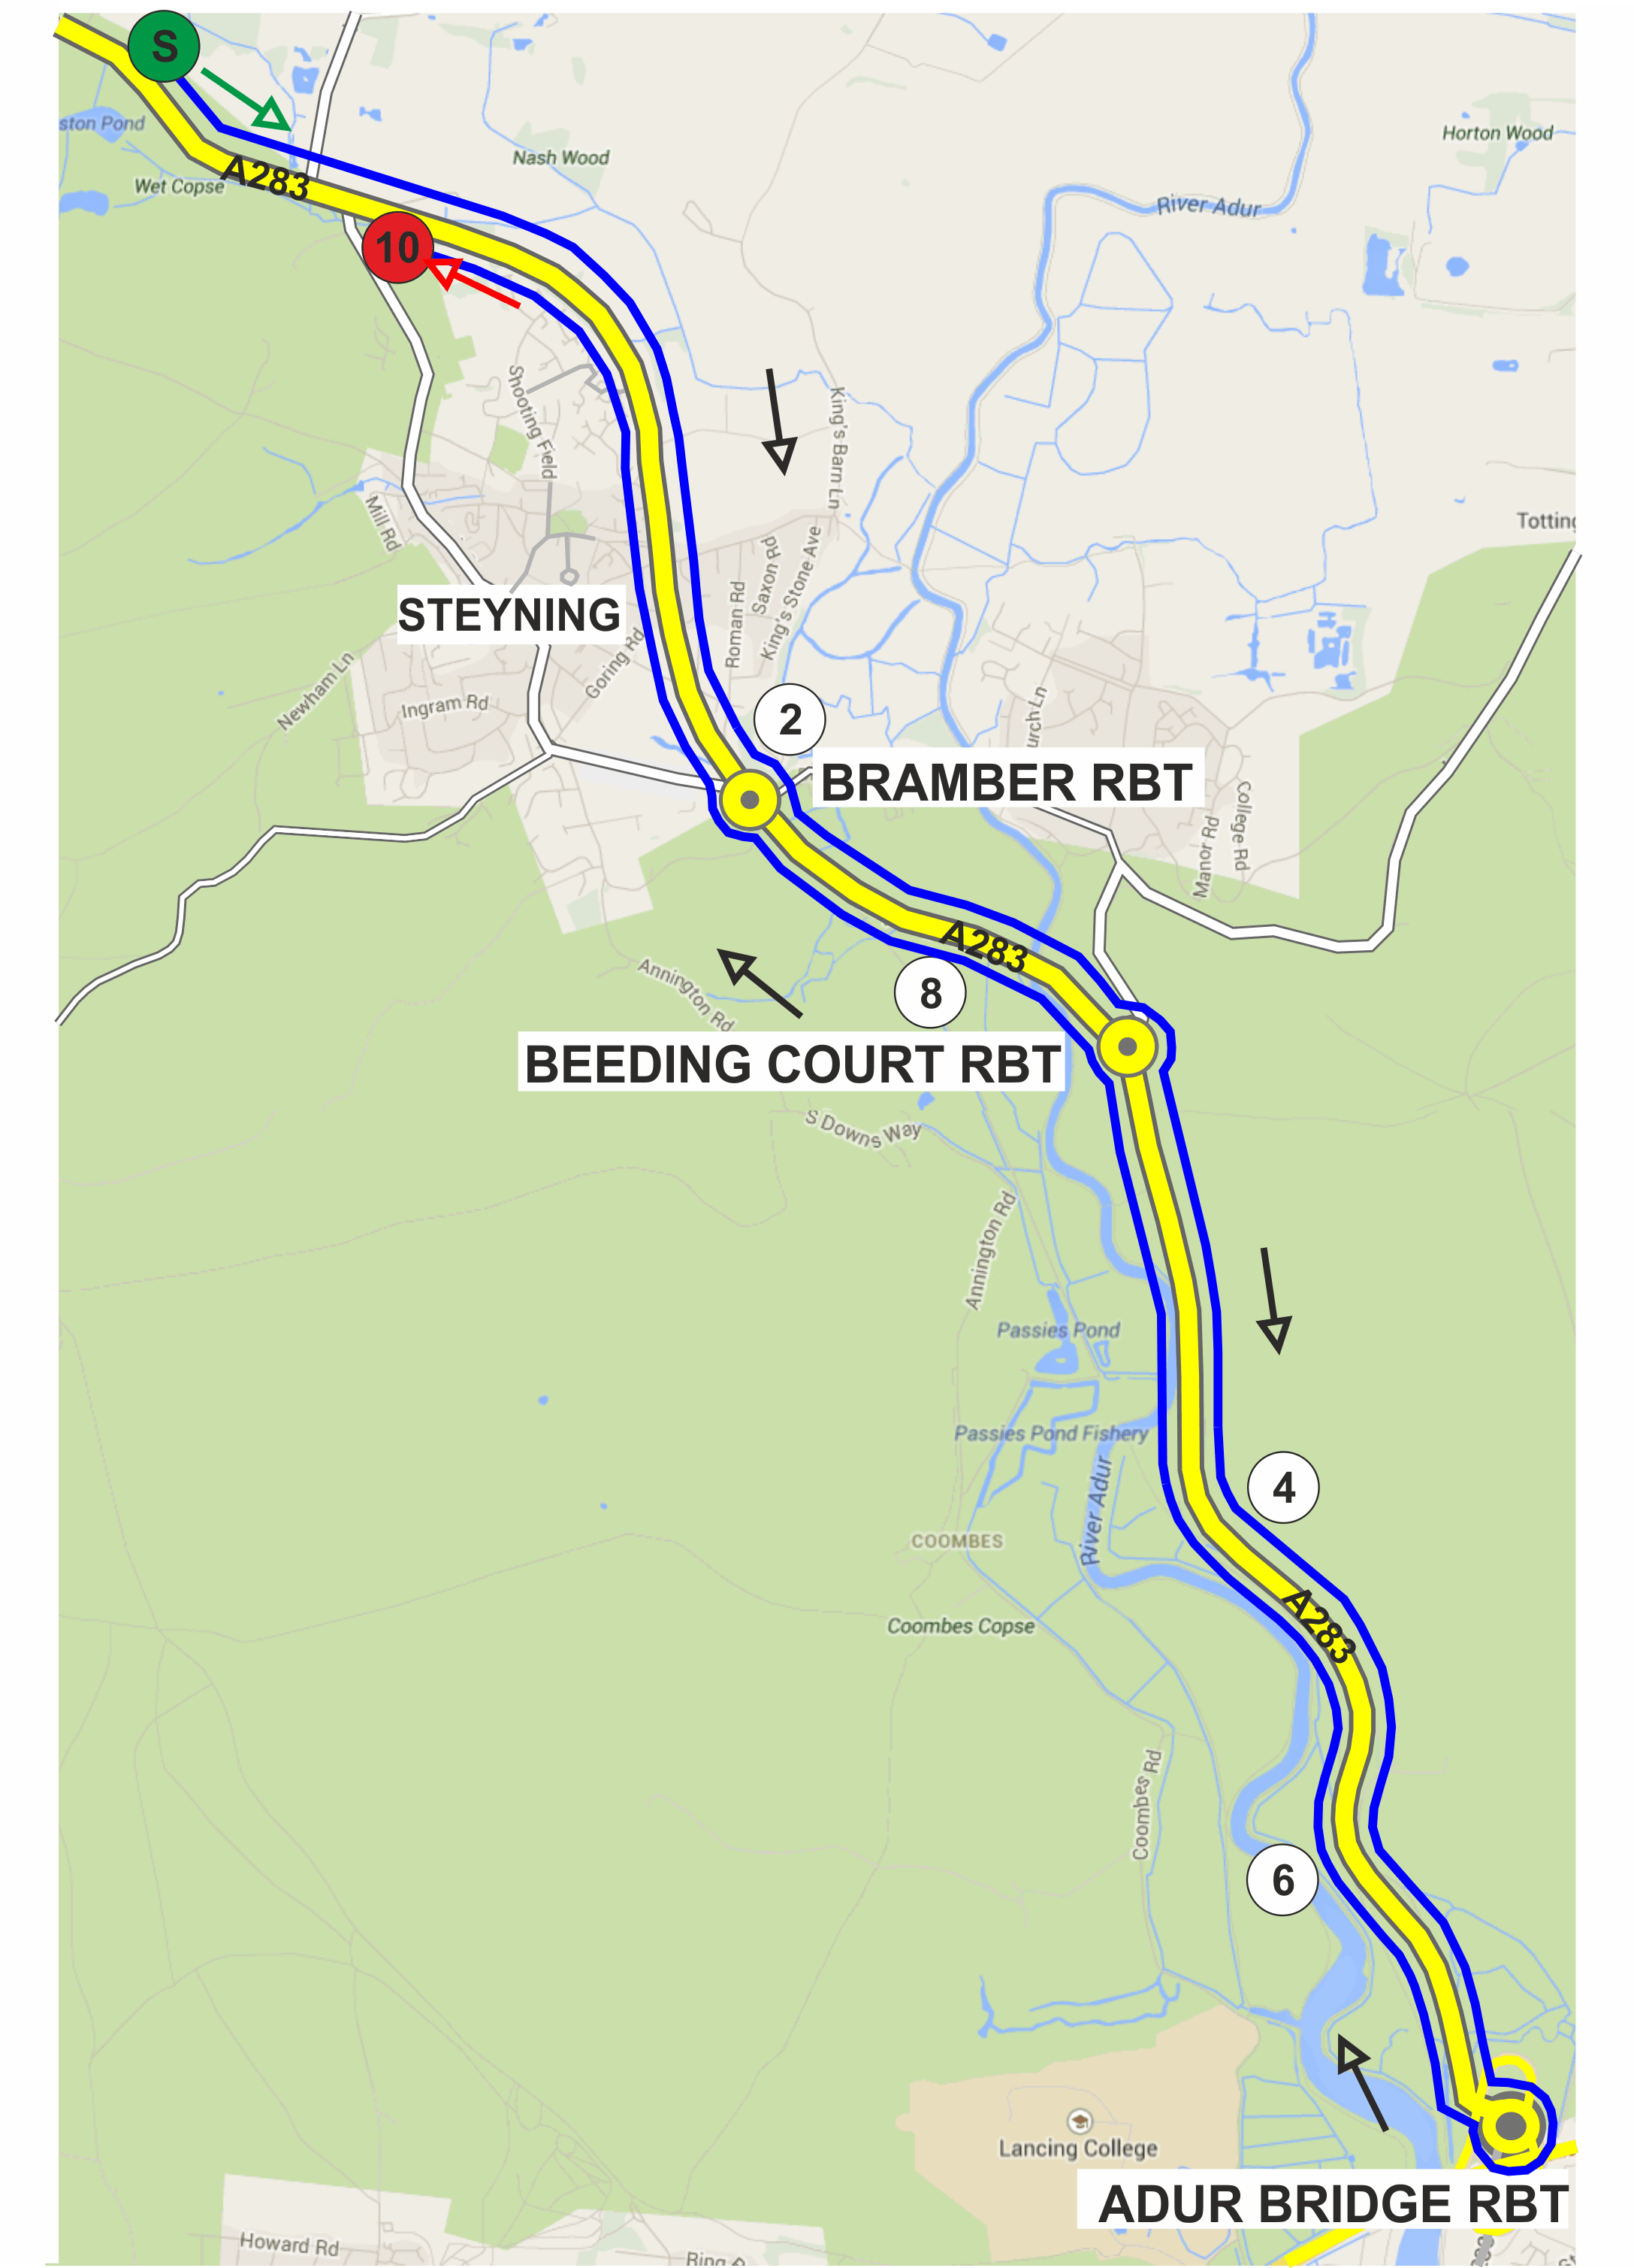

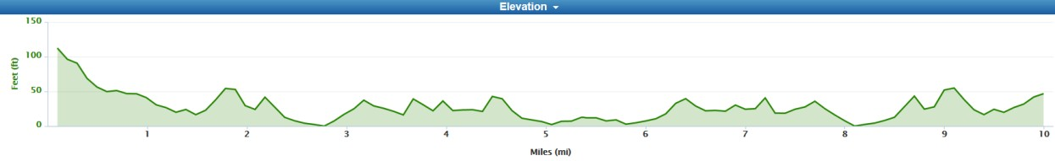

bib | start_time | firstname | lastname | club | gender | category
1 | 07:01:00 | Robin | Johnson | Brighton Mitre CC | Male | Veteran
2 | 07:02:00 | Ian | Cheesman | Worthing Excelsior CC | Male | Veteran
3 | 07:03:00 | Max | Everest | Sussex Revolution Velo Club | Male | Senior
4 | 07:04:00 | Julian | Scutter | East Grinstead CC | Male | Veteran
5 | 07:05:00 | Stuart | Bettis | HuntBikeWheels.com | Male | Senior
6 | 07:06:00 | Richard | Cartland | HuntBikeWheels.com | Male | Veteran
7 | 07:07:00 | Robb | Cunningham | Brighton Mitre CC | Male | Veteran
8 | 07:08:00 | Henry | Weaver | Southborough & Dist. Whs | Male | Junior
9 | 07:09:00 | Georgina | Wise | Crawley Wheelers | Female | Senior
10 | 07:10:00 | Daniel | Quinn | South London Harriers | Male | Veteran
11 | 07:11:00 | Cris | Coxon | Brighton Mitre CC | Male | Veteran
12 | 07:12:00 | Martin | Slater | 34 Nomads CC | Male | Veteran
13 | 07:13:00 | Tracey | Williams | Brighton Mitre CC | Female | Veteran
14 | 07:14:00 | Mark | Range | Horsham Cycling | Male | Veteran
15 | 07:15:00 | Mike | Finch | HuntBikeWheels.com | Male | Senior
16 | 07:16:00 | Llewellyn | Thomas | Brighton Mitre CC | Male | Senior
17 | 07:17:00 | Richard | Keevil | GS Stella | Male | Veteran
18 | 07:18:00 | Alan | Robinson | Central Sussex CC | Male | Veteran
19 | 07:19:00 | Richard | Harris | 34 Nomads CC | Male | Veteran
20 | 07:20:00 | Caitlin | Bower | HuntBikeWheels.com | Female | Senior
21 | 07:21:00 | Robert | Clegg | Horsham Cycling | Male | Veteran
22 | 07:22:00 | Ryan | Machin | Crawley Wheelers | Male | Veteran
23 | 07:23:00 | John | McDonald | trainSharp | Male | Veteran
24 | 07:24:00 | Peter | Phipps | ...a3crg | Male | Veteran
25 | 07:25:00 | Jack | Smith | Brighton Mitre CC | Male | Senior
26 | 07:26:00 | Glen | Whittington | Southborough & Dist. Whs | Male | Senior
27 | 07:27:00 | Rory | Knapp | Brighton Mitre CC | Male | Senior
28 | 07:28:00 | Chris | Beales | Velo 1860 | Male | Veteran
29 | 07:29:00 | Paul | McDaid | CC Bexley | Male | Veteran
30 | 07:30:00 | Nik | Allen | Team TMC | Male | Veteran
31 | 07:31:00 | Dan | Ellis | BTNRT | Male | Senior
32 | 07:32:00 | Ferenc | File | Horsham Cycling | Male | Senior
33 | 07:33:00 | Peter | Noble | Epsom CC | Male | Veteran
34 | 07:34:00 | Rick | Hughes | Worthing Excelsior CC | Male | Veteran
35 | 07:35:00 | David | Pollard | VTTA (Surrey/ Sussex) | Male | Veteran
36 | 07:36:00 | Paul | Tippett | Crawley Wheelers | Male | Veteran
37 | 07:37:00 | Rob | Luff | GS Stella | Male | Veteran
38 | 07:38:00 | Lewis | Reeves | Horsham Cycling | Male | Senior
39 | 07:39:00 | Paul | Fletcher | trainSharp | Male | Veteran
40 | 07:40:00 | Andy | Critchlow | Norwood Paragon CC | Male | Veteran
41 | 07:41:00 | Sam | Dix | trainSharp | Male | Veteran
42 | 07:42:00 | Paul | Thatcher | Brighton Mitre CC | Male | Veteran
43 | 07:43:00 | Luke | Goodwill | VC de Londres | Male | Junior
44 | 07:44:00 | Paul | Batten | Crawley Wheelers | Male | Senior
45 | 07:45:00 | Richard | Tully | Elite Cycling | Male | Veteran
46 | 07:46:00 | George | Welfare | Eastbourne Rovers CC | Male | Senior
47 | 07:47:00 | Jacob | Rubio | HuntBikeWheels.com | Male | Senior
48 | 07:48:00 | Scott | Warden | Charlotteville Cycling Club | Male | Senior
49 | 07:49:00 | Chris | Lord | Brighton Excelsior CC | Male | Veteran
50 | 07:50:00 | Matthew | Smith | Team TMC | Male | Senior
51 | 07:51:00 | David | Clark | Eastbourne Rovers CC | Male | Veteran
52 | 07:52:00 | Ian | Hayward | HuntBikeWheels.com | Male | Veteran
53 | 07:53:00 | Dougi | Hall | Border City Whs CC | Male | Veteran
54 | 07:54:00 | Kevin | Plummer | Team TMC | Male | Veteran
55 | 07:55:00 | Joshua | Golliker | trainSharp Development Team | Male | Junior
56 | 07:56:00 | Mark | Bashford | East Grinstead CC | Male | Senior
57 | 07:57:00 | Lucas | Houghton | Team TMC | Male | Junior
58 | 07:58:00 | Joe | Benians | Lewes Wanderers CC | Male | Senior
59 | 07:59:00 | Tom | Houghton | Team TMC | Male | Veteran
60 | 08:00:00 | Simon | McNamara | HuntBikeWheels.com | Male | Veteran
61 | 08:01:00 | Sally | Turner | trainSharp | Female | Veteran
62 | 08:02:00 | Steven | Kane | Team TMC | Male | Senior
63 | 08:03:00 | Christopher | McNamara | Nuun-Sigma Sport-London RT | Male | Veteran
 | Tandem team
64 | 08:04:00 | Mark | Jones | GS Stella | Male | Veteran
65 | 08:04:00 | Tony | Reeves | GS Stella | Male | Veteran

